Wireshark Lab 9

Socket Programming FTP

Suraj Durgesht

(16EC06)

Instructor: Dr. Rajendra Hegadi

# -*- coding: utf-8 -*-

"""

Created on Mon Oct 15 14:01:29 2018

@author: Suraj

file transfer TCP Server

"""# server2.py

import socket

from threading import Thread #from SocketServer import ThreadingMixIn

TCP_IP = '192.168.0.167'

TCP_PORT = 9001

TCP_PORT1 = 9002

BUFFER_SIZE = 1024

class ClientThread(Thread):

def __init__(self,ip,port,sock):

Thread.__init__(self)

self.ip = ip

self.port = port

self.sock = sock

print (" New thread started for "+ip+":"+str(port))

def run(self):

filename='mytext.txt'

f = open(filename,'rb')

while True:

l = f.read(BUFFER_SIZE)

while (l):

self.sock.send(l)

#print('Sent ',repr(l))

l = f.read(BUFFER_SIZE)

if not l:

f.close()

self.sock.close()

break

tcpsock = socket.socket(socket.AF_INET, socket.SOCK_STREAM)

tcpsock.setsockopt(socket.SOL_SOCKET, socket.SO_REUSEADDR, 1)

tcpsock.bind(('', TCP_PORT1))

threads = []

while True:

tcpsock.listen(5)

print( "Waiting for incoming connections...")

(conn, (ip,port)) = tcpsock.accept()

print ('Got connection from ', (ip,port))

newthread = ClientThread(ip,port,conn)

newthread.start()

threads.append(newthread)

for t in threads:

t.join()

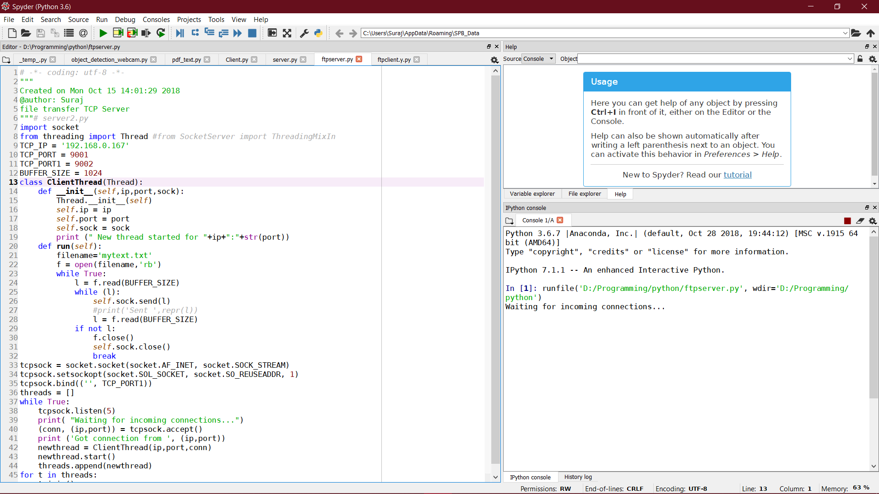

# -*- coding: utf-8 -*-

"""

Created on Mon Oct 15 14:05:59 2018

file transfer TCP client

@author: Suraj

"""

import socket

TCP_IP = '192.168.0.167'

TCP_PORT = 9001

BUFFER_SIZE = 1024

s = socket.socket(socket.AF_INET, socket.SOCK_STREAM)

s.connect((TCP_IP, TCP_PORT))

with open('received_file', 'wb') as f:

print ('file opened')

while True:

#print('receiving data...')

data = s.recv(BUFFER_SIZE)

print('data=%s', (data))

if not data:

f.close()

print ('file close()')

break

# write data to a file

f.write(data)

print('Successfully get the file')

s.close()

print('connection closed')

